Assignment 7.1:

Calculate the number of employees corresponding to each skill from the table 'employee' which is

loaded in the Demo.

* Create file employee_details.txt in the local folder.
* Create database: create database employee;
* Use database: use employee;
* Create table: create table employee (name String, skills String, level int, city

String) row format delimited fields terminated by ‘,’;

* Load file data

into table: load data local inpath

‘home/acadgild/manjunath/employee_details’ into table

employee;

* To view table data: select *from employee;

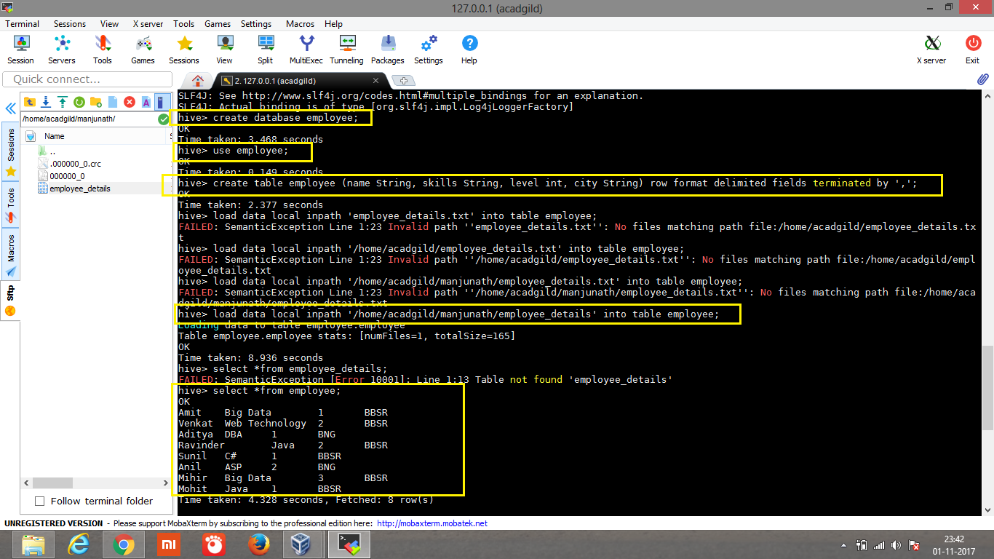

* Calculate the number of employees corresponding to each skill from the table 'employee'.

Query: select skills, count (name) from employee group by skills;

